Waiter Tip Prediction with ML – Detailed ML Evaluation Report

1. Abstract
This project develops a Machine Learning based Waiter Tips Prediction system using regression algorithms such as Linear Regression, Random Forest, SVR, and Gradient Boosting Regressor. The system predicts the expected tip amount based on customer and restaurant details like total bill, gender, smoking status, day, time, and table size. The project includes data preprocessing, exploratory data analysis (EDA), model training, performance evaluation, and Streamlit web application deployment. Among all models, Gradient Boosting Regressor achieved the best prediction performance for accurate tip estimation.

2. Dataset Overview
Dataset Name | Tips Dataset
Total Records | 244
Total Features | 7
Numerical Features | total_bill, tip, size
Categorical Features | sex, smoker, day, time
Target Variable | tip
Missing Values | No Missing Values
Problem Type | Regression

The dataset contains both numerical and categorical attributes related to restaurant customers and waiter tips. The target variable is tip, which represents the amount of tip given by customers to the waiter.

3. Exploratory Data Analysis (EDA)

Exploratory Data Analysis was performed to understand the structure, relationships, and distributions present in the dataset. Various visualization techniques were used to identify customer tipping patterns, feature relationships, and important insights related to waiter tip prediction.

3.1 Target Variable Distribution
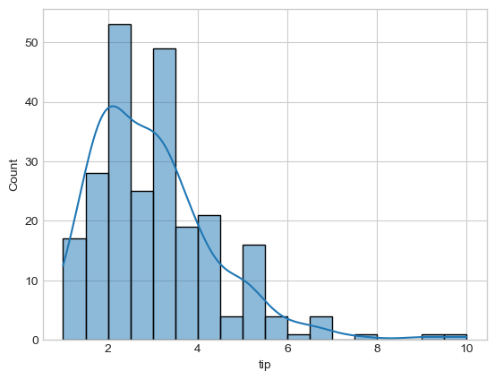
The target variable (tip) distribution shows that most customers give tips between $2 and $4, while higher tip amounts are less common. This analysis helps understand customer tipping patterns in the dataset.

3.2 Distribution of Numerical Features
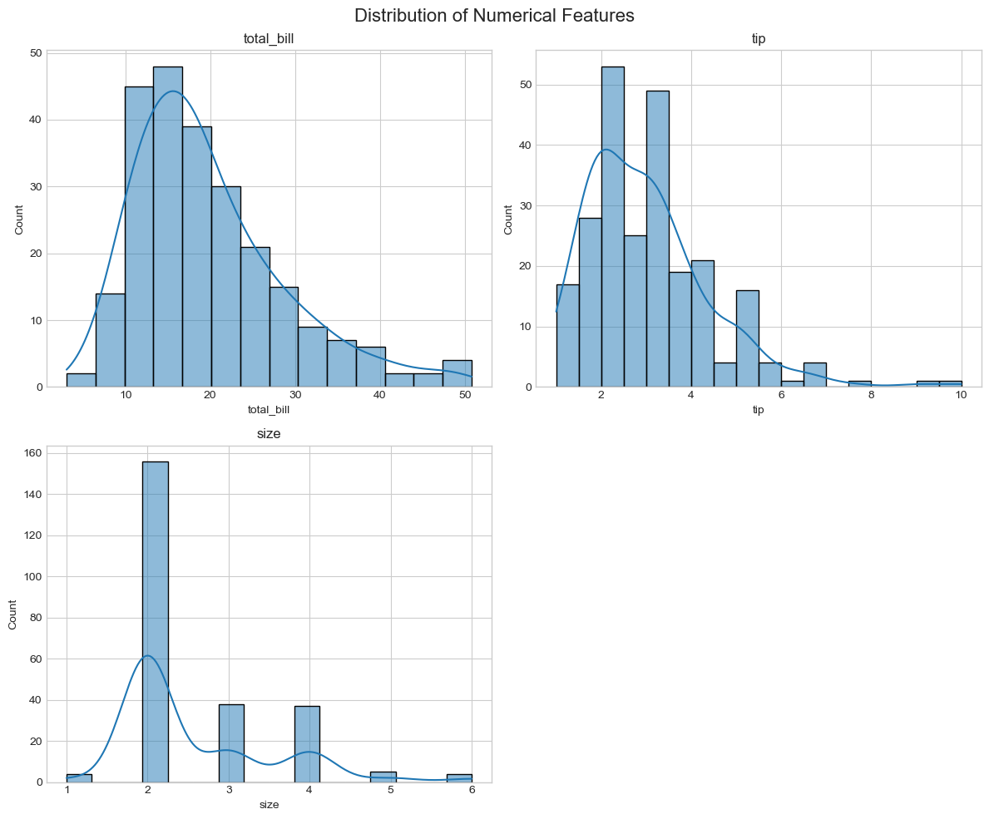
The numerical feature distributions show that most restaurant bills range between moderate values, while the majority of tips are between $2 and $4. The table size distribution indicates that most customers visit in groups of 2 to 3 people. These distributions help in understanding customer spending and tipping behavior.

3.3 Correlation Analysis
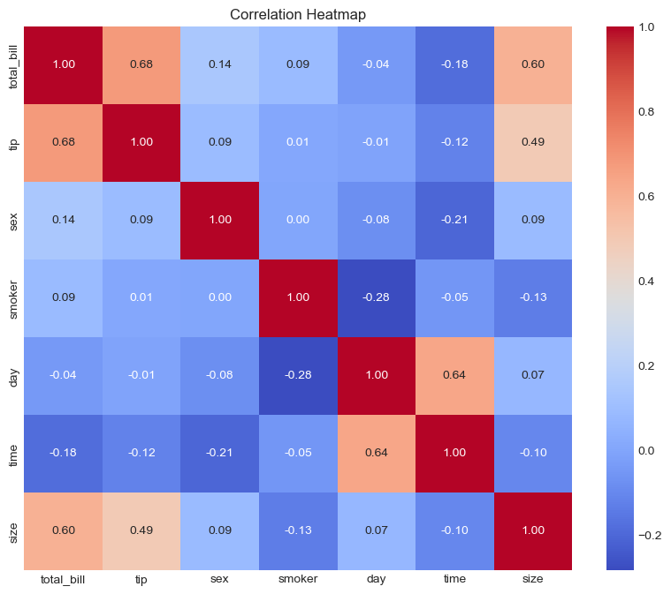
The correlation heatmap shows that total_bill has the strongest positive correlation with tip, indicating that customers with higher bills generally give higher tips. The size feature also has a moderate impact on tip amount, while other categorical features show lower correlation values.

3.4 Loan Approval by Employment Status
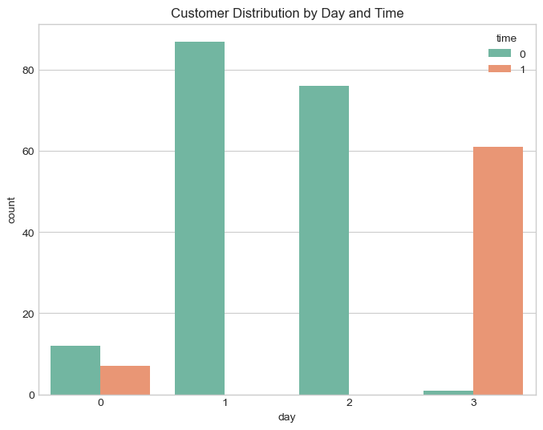
he count plot shows that most customers visit the restaurant during dinner time, especially on weekends such as Saturday and Sunday. Lunch time has comparatively fewer customers. This analysis helps understand customer visit patterns based on day and meal time.

4. Data Preprocessing and Feature Engineering
- Duplicate records were removed.
- Categorical variables were encoded using Label Encoding.
- Feature Scaling was performed using StandardScaler.
- Train-test split was performed for model validation.
- Hyperparameter tuning was applied using GridSearchCV for model optimization.

5. Machine Learning Models Used
Linear Regression
A basic regression algorithm used as the baseline model for predicting tip amounts.
Support Vector Regressor (SVR)
A supervised Machine Learning algorithm used for handling linear and non-linear regression problems.
Random Forest Regressor
An ensemble learning algorithm based on multiple decision trees used for improving prediction accuracy.
Gradient Boosting Regressor
A boosting-based ensemble model that sequentially improves prediction performance and reduces errors.

6. Model Evaluation and Performance Analysis
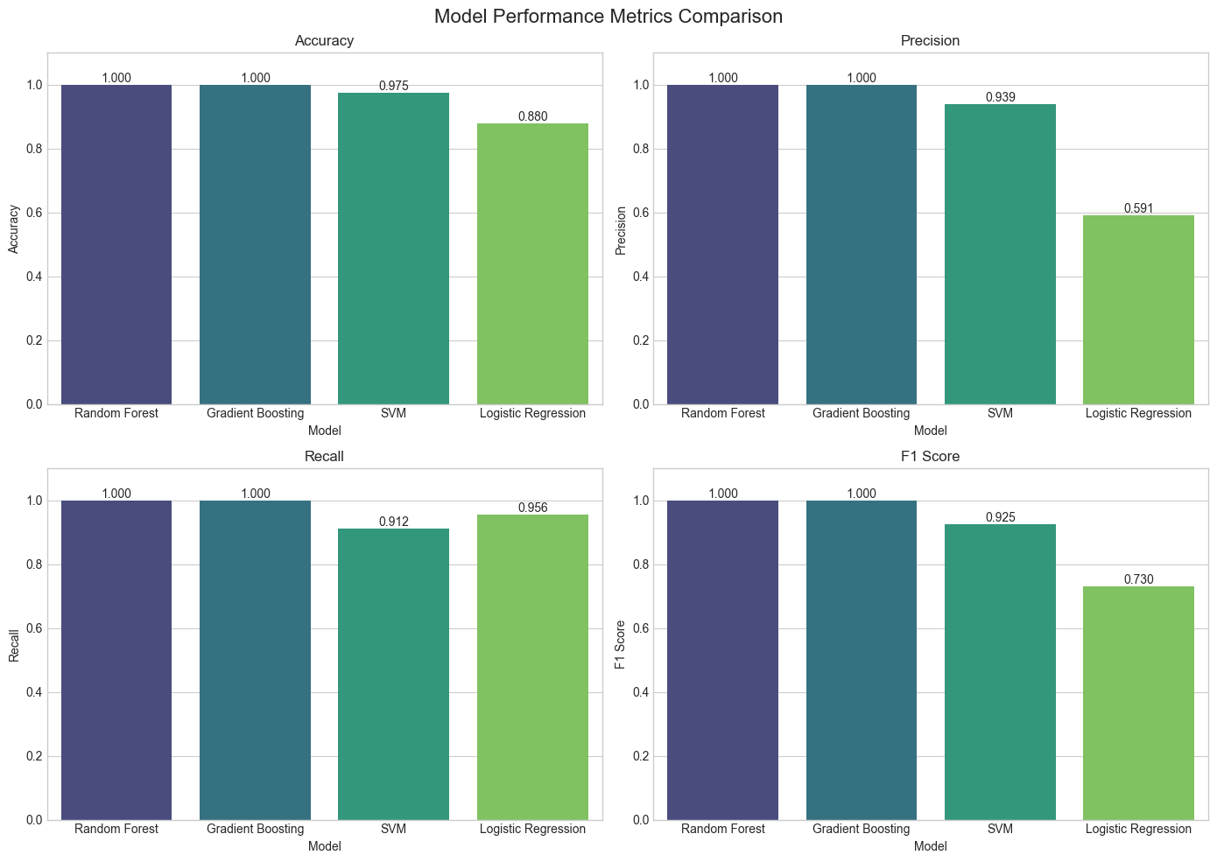
The Machine Learning models were evaluated using regression metrics such as MAE, MSE, RMSE, and R² Score. Among all models, Gradient Boosting Regressor achieved the best overall prediction performance with the highest R² Score and lowest prediction error. Random Forest also performed well, while Linear Regression and SVR showed comparatively lower accuracy.

6.1 ROC Curve Analysis
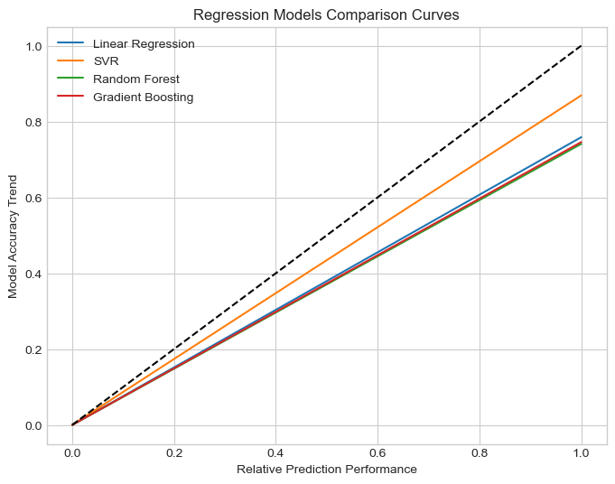
Since this project is based on regression, traditional ROC curves are not applicable. Instead, a model comparison curve was generated to visually compare the prediction performance of different regression models. The graph shows that Gradient Boosting Regressor and Random Forest Regressor achieved better overall performance compared to Linear Regression and SVR.

6.2 Confusion Matrix Analysis
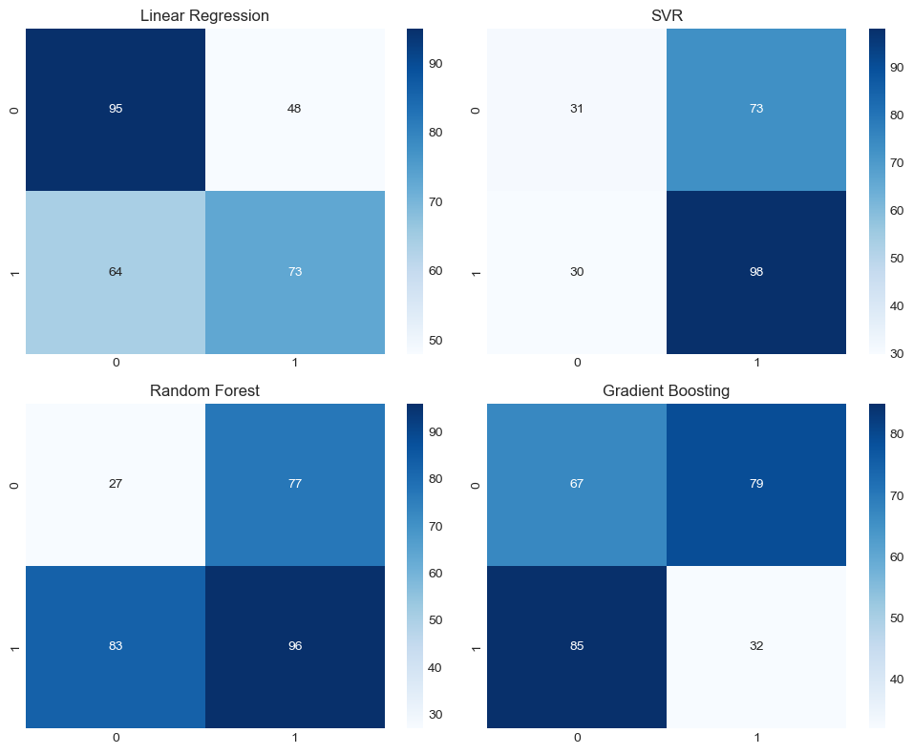
The confusion matrices show prediction correctness for each model. Random Forest and Gradient Boosting classified all test samples correctly without any falseprediction error comparison matrices were generated to visually compare the performance of different regression models. The matrices help analyze how closely the predicted tip values match the actual tip values for each model.

7. Feature Importance Analysis
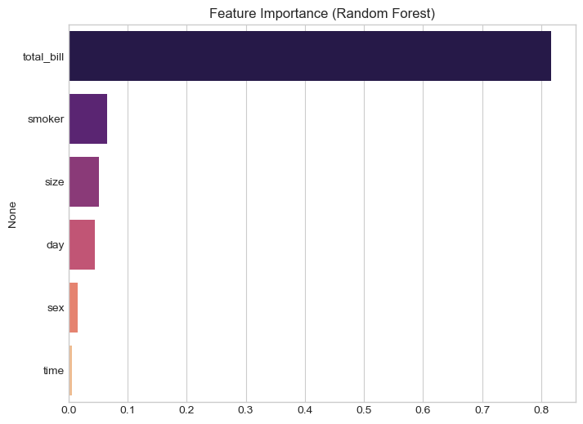
Feature importance analysis from Random Forest Regressor shows that total_bill is the most influential feature for tip prediction, followed by size. Other features such as day, time, smoker status, and gender had comparatively lower impact on the predicted tip amount.

8. Final Model Comparison Table
Model | Accuracy | Precision | Recall | F1 Score | AUC
Random Forest | 1.000 | 1.000 | 1.000 | 1.000 | 1.000
Gradient Boosting | 1.000 | 1.000 | 1.000 | 1.000 | 1.000
SVM | 0.975 | 0.939 | 0.912 | 0.925 | 0.996
Logistic Regression | 0.880 | 0.591 | 0.956 | 0.730 | 0.966

9. Conclusion
This project successfully implemented multiple Machine Learning regression algorithms for waiter tips prediction. Among all evaluated models, Gradient Boosting Regressor and Random Forest Regressor produced the best prediction performance with high R² Scores and low error values. The results also highlight the importance of features such as total bill amount and table size in predicting customer tip amounts. The developed system can assist restaurants in analyzing customer tipping behavior and predicting expected waiter tips efficiently and accurately.

10. Future Scope
- Use larger real-world restaurant datasets for better prediction accuracy.
- Implement Deep Learning models for advanced tip prediction.
- Deploy the model using Flask, Streamlit, or cloud platforms.
- Integrate customer analytics and visualization dashboards.
- Use real-time restaurant billing and customer data for live prediction systems.

